Task 2.2: Adding Style to the Webpages Using CSS
Overview
In this task, I will created an external CSS file to add styling and colors to the HTML pages. The component colors, font colors, and typography should be consistent with my choices in Task 1 and appropriate to the client description provided in the client scenario and criteria. The majority of the styling should be incorporated using an external CSS file. Inline and/or internal CSS styling can only be used when needed but should be minimal. I Documented any issues or errors I encountered in my code development that prevented my stylesheet or webpages from functioning as intended.

Instructions
Provide responses in the following table.

Rendered Homepage Screenshot
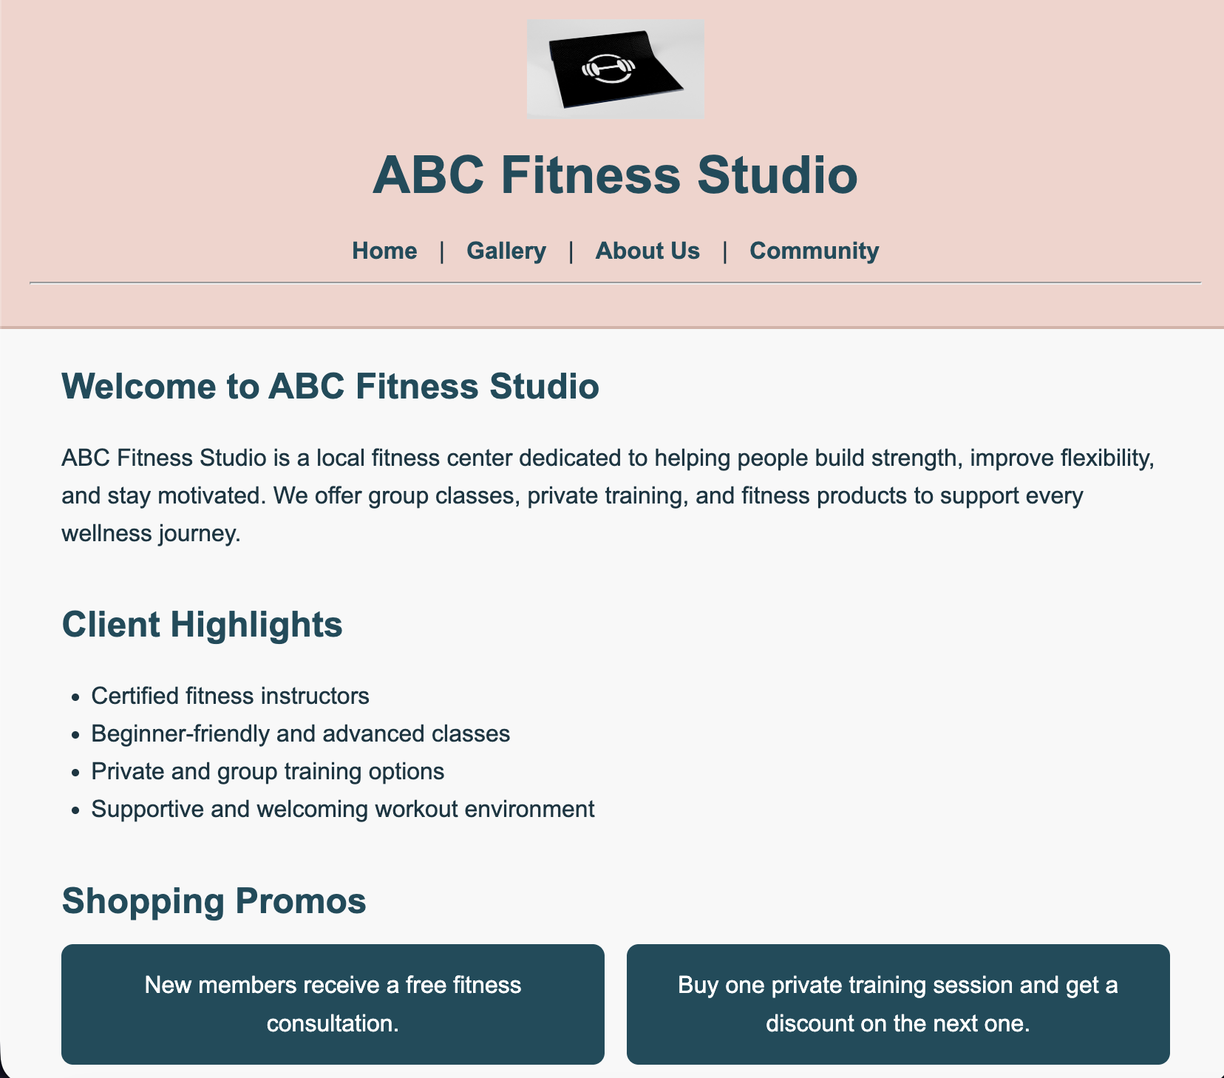

Homepage Analysis
The homepage was styled to create a welcoming and energetic first impression for ABC Fitness Studio. The header and footer use a light pink background to create a clean and approachable look, while the dark teal font color improves readability and gives the website a professional fitness brand feel. The promo section is organized in bordered boxes so each promotional message stands out clearly. The featured class images are displayed horizontally to create visual balance, and the shopping perks section uses a gold background to draw attention to important benefits. The service categories are arranged in a simple grid to make the page easy to scan.

Rendered Gallery Page Screenshot
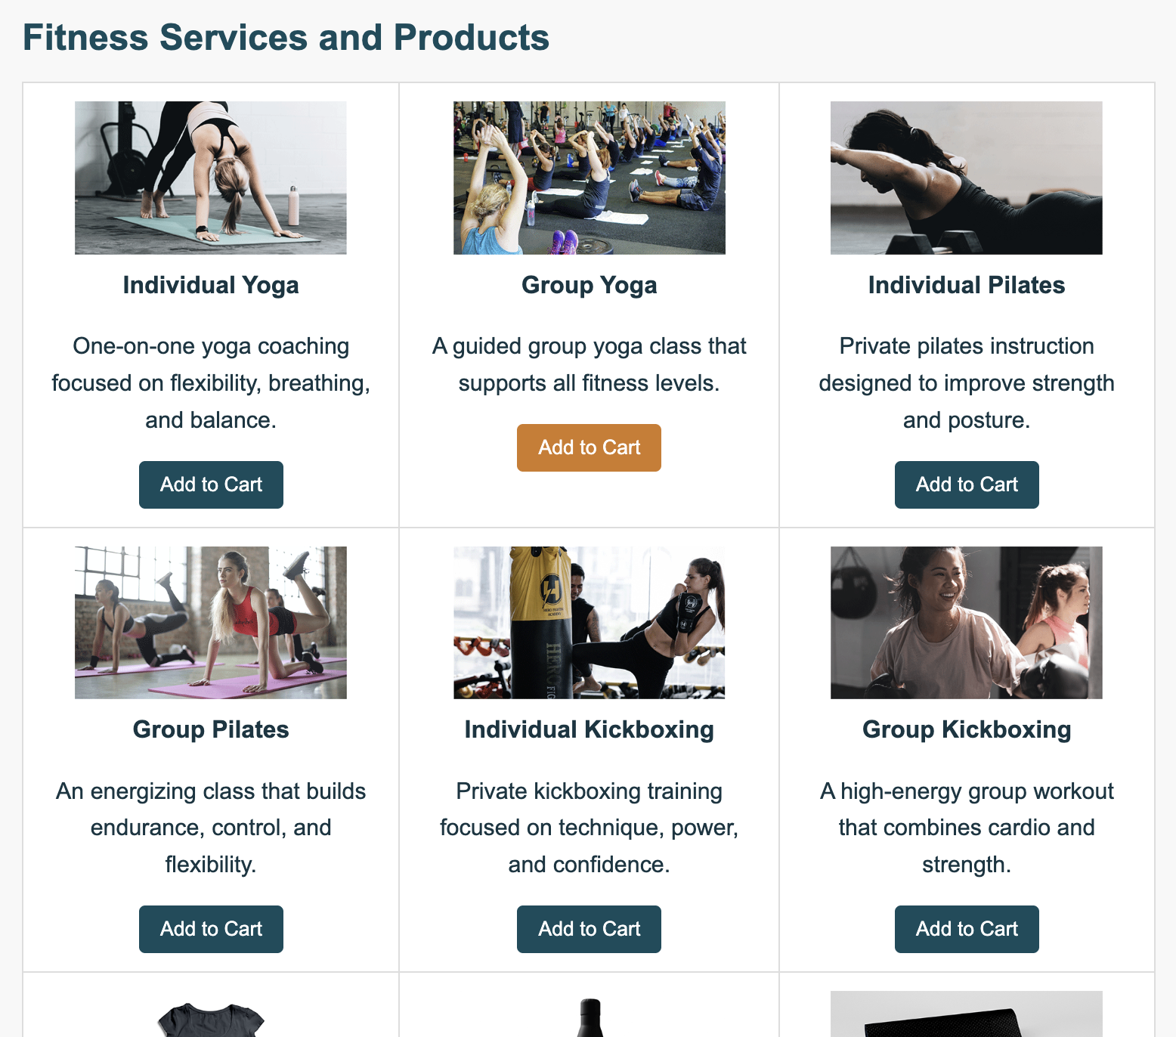

Gallery Page Analysis
The gallery page was styled to present services and products in a clear tabular layout. Each table cell centers the image, title, description, and button so the page looks organized and easy to compare. The “View Shopping Cart” button is placed near the top for visibility. The buttons use the same teal and gold hover styling as the rest of the website to create consistency. Borders, spacing, and alignment help separate each item visually and improve readability.

Rendered About Us/Contact Page Screenshot
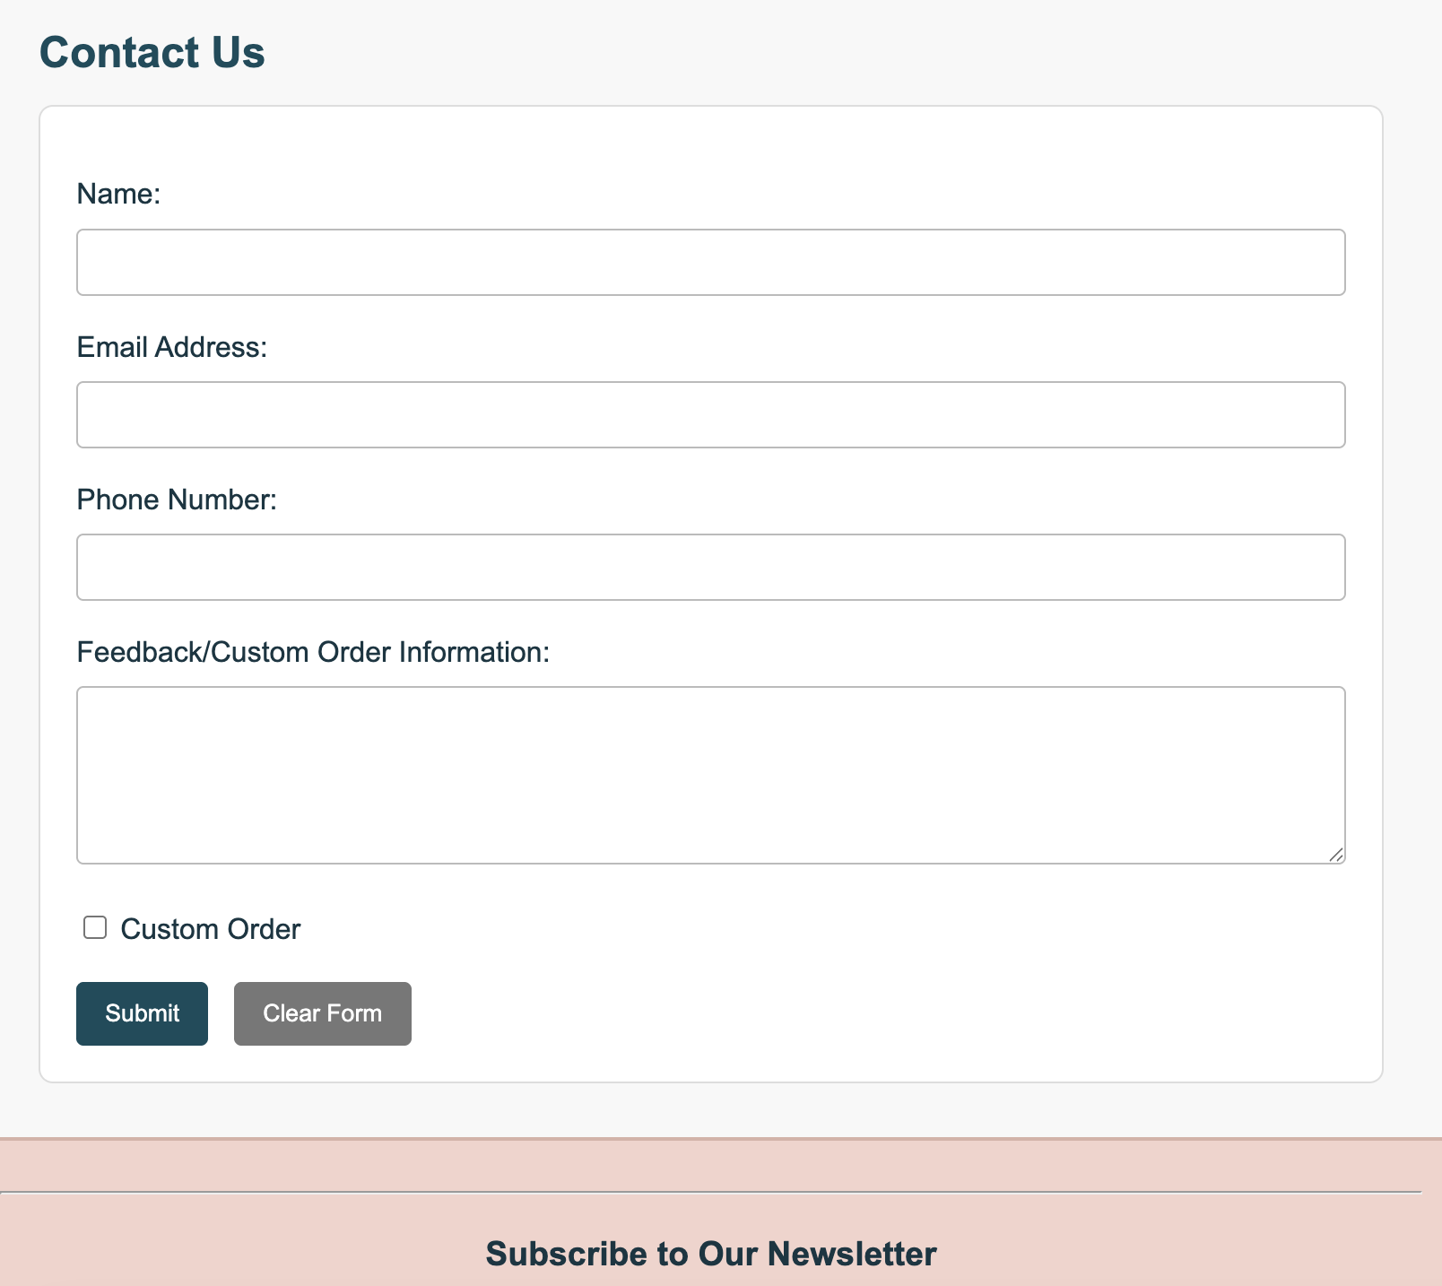

About Us/Contact Page Analysis
The About Us page was styled to make business information and the contact form easy to read and use. The business hours table stretches across the page and centers the content to keep it neat and structured. The form fields are styled with full-width inputs, spacing, and rounded borders to improve usability. The submit button uses the primary teal color, while the clear button uses gray to visually distinguish the actions. This styling supports both clarity and ease of interaction.

Rendered Custom Page Screenshot
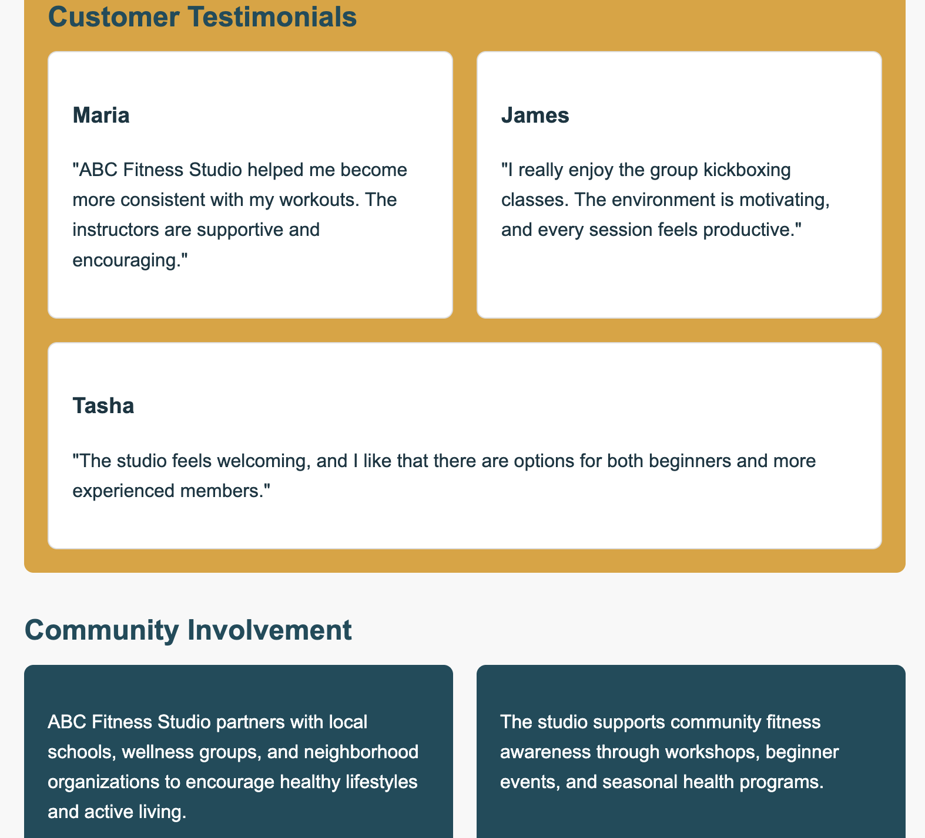

Custom Page Analysis
The custom page was styled to strengthen the studio’s community identity. The testimonial section uses bordered white cards on a gold background so each testimonial stands out clearly. The community involvement section uses teal boxes with white text to create contrast and visual emphasis. Spacing and grouped boxes help organize the content into distinct sections. This styling supports the fitness studio’s welcoming and community-focused image.

Accessibility Analysis
Accessibility practices were followed by using clear page structure, descriptive headings, and readable font choices. Color choices were selected for contrast so text remains legible against the background. Images use alt text so screen readers can describe the content to users with visual impairments. Navigation links are consistent across all pages, which supports predictability and ease of use. Buttons and form fields are clearly labeled, and spacing between elements makes the pages easier to read and interact with. These choices help make the website more usable for a wider range of users. The task specifically asks for accessibility analysis, and the sample also shows that you should explain more than just color choices.

Responsive Web Design Analysis
To make the website responsive for mobile devices, the viewport meta tag should be included in the head of each page so the layout matches the device width. Flexible layouts such as grids and flexbox can be adjusted with media queries to stack content vertically on smaller screens. Images should use max-width settings so they resize within their containers. Navigation links can wrap or stack to fit narrow screens more comfortably. The gallery table can be adjusted to display items as block sections on smaller devices. These changes would help the website remain readable and usable across desktop, tablet, and mobile screens. The template specifically asks for a mobile responsiveness explanation.

Testing and Error Reporting

Record details of the error from the IDE. While styling the pages, I initially had issues with some colors not looking readable against the background and with spacing between sections appearing uneven.
Description of what I attempted in order to fix the error. I tested different color combinations and adjusted spacing, padding, and margins in the external CSS file until the content looked more balanced and readable. I also reviewed the pages after each change to make sure the layout remained consistent across the homepage, gallery, About Us page, and custom page.

